PRODUCT INFORMATION FILE*

RégimA

Zone Age Reversal Night Complex

Prepared: 19 November 2015
(Label & packaging update August 2021)

*As required under Article 11 of the European Cosmetics Regulation EC No. 1223/2009
TABLE OF CONTENTS

Contents
INTRODUCTION 3
PRODUCT DESCRIPTION 3
COSMETIC PRODUCT SAFETY REPORT 7
Part A: Cosmetic Product Safety Information 7
A.1 Quantitative and qualitative composition of the cosmetic product: 7
A.2 Physical /chemical characteristics and stability of the cosmetic product 11
A.3 Microbiological Quality 12
A.4 Impurities, traces, information about the packaging material 12
A.5 Normal and reasonably foreseeable use 12
A.6 Exposure to the Cosmetic Product 12
A.7 Exposure to the Substances 13
A.8 Toxicological Profile of the Substances 15
A.9 Undesirable Effects and Serious Undesirable Effects 19
A.10 Information on the Cosmetic Product 19
B: Part Cosmetic Product Safety Assessment 20
B.1 Assessment Conclusion 20
B.2 Label Warnings and Instructions for Use 20
B.3 Reasoning 21
B.4 Assessors Credentials and Approval of Part B 21
List of References 21
METHOD OF MANUFACTURE / GMP CERTIFICATION 22
PROOF OF EFFECT CLAIMED 23
ANIMAL TESTING STATEMENT 23
Appendix 1: Safety Data Sheets or Ingredient Specifications 24
Appendix 2: Microbial Challenge Test 25
Appendix 3: Certificates of Allergen Content 26
Appendix 4: Miscellaneous 27

INTRODUCTION

PRODUCT DESCRIPTION

Product Name: Zone Age Reversal Night Complex

Product type | Anti-Ageing Night Cream
Form | Cream
Colour | Pale Yellow
Pack size | 50 mL
Pack type | WSZ Airless Bottle
Dispenser type | Bottle with pump dispenser
Part of a set | No
Manufacturer code | NBN005
Normal use | Leave-on face cream

Pictures of the Item: On following page

Container label

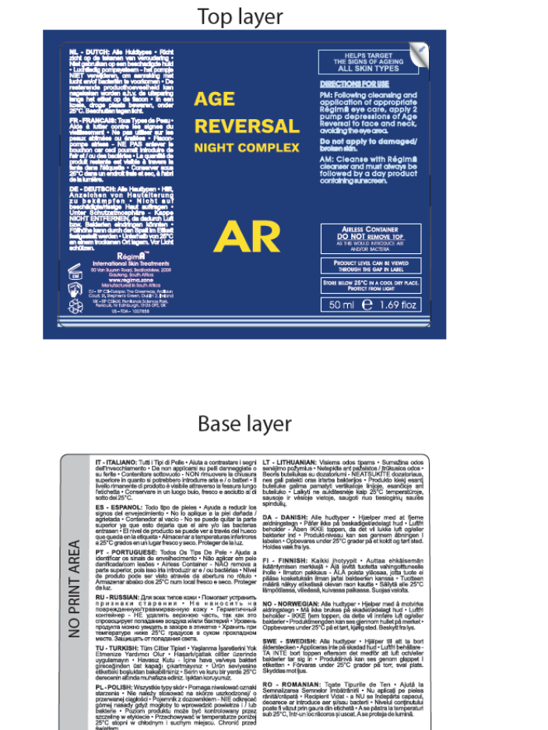
Carton label
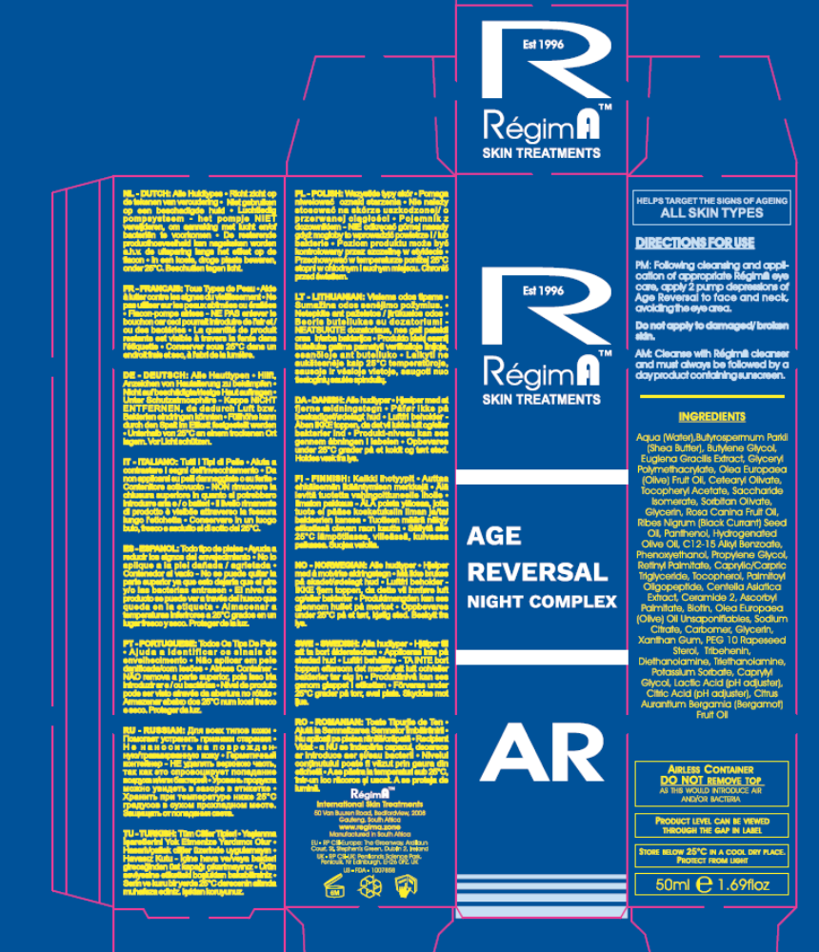

Batch code: The batch number is printed onto the underside of the carton and the container at the point of manufacturing and filling, therefore it is not visible on the label as represented in this PIF. The batching is automated, so the batch code and date is printed onto the carton and container as they are filled and boxed.

Product claims:

This product claims to help target the signs of ageing.

COSMETIC PRODUCT SAFETY REPORT

Part A: Cosmetic Product Safety Information

A.1 Quantitative and qualitative composition of the cosmetic product:

Zone Age Reversal Night Complex base formula

No | Raw Ingredient (INCI Name) | % (w/w) | Mixture % w/w Wt(g/kg) | CAS | EC | Function | Supplier (Agent) | Tradename
1 | Sorbitan Olivate | 2.400 | 6.000 | 92202-01-2  223706-40-9 | 296-033-5 | Primary Emulsifier | Hallstar | Olivem 1000
1 | Cetearyl Olivate | 3.600 | 6.000 | 85116-80-9 | 285-532-3 | Primary Emulsifier | Hallstar | Olivem 1000
2 | Butyrospermum Parkii (Shea Butter) | 5.000 | 5.000 | 68920-03-6 194043-92-0  91080-23-8 | 293-515-7 | Skin Conditioning | AA Fratelli Parodi | Cetiol SB-45
3 | Centella Asiatica Extract | 0.0875 | 5.000 | 84696-21-9 | 283-640-5 | Skin Conditioning | Greentech (Natchem) | Cosmelene of Centella
3 | Butylene Glycol | 4.9125 | 5.000 | 107-88-0 | 203-529-7 | Skin Conditioning | Greentech (Natchem) | Cosmelene of Centella
4 | Palmitoyl Oligopeptide | 0.0005 | 5.000 | 147732-56-7  171263-26-6 | # | Skin Conditioning/ Viscosity controlling | Sederma | Biopeptide CL
4 | Propylene Glycol | 1.000 | 5.000 | 57-55-6 | 200-338-0 | Skin Conditioning/ Viscosity controlling | Sederma | Biopeptide CL
4 | Glyceryl Polymethacrylate | 3.9995 | 5.000 | 146126-21-8  28474-30-8 | # | Skin Conditioning/ Viscosity controlling | Sederma | Biopeptide CL
5 | Citric Acid | 0.050 | 5.000 | 77-92-9 | 201-069-1 | Humectant | DSM Nutritional Products (Chempure) | Pentavitin
5 | Sodium Citrate | 0.050 | 5.000 | 68-04-2 | 200-675-3 | Humectant | DSM Nutritional Products (Chempure) | Pentavitin
5 | Aqua | 2.400 | 5.000 | 7732-18-5 | 231-791-2 | Humectant | DSM Nutritional Products (Chempure) | Pentavitin
5 | Saccharide Isomerate | 2.500 | 5.000 | 100843-69-4 | - | Humectant | DSM Nutritional Products (Chempure) | Pentavitin
6 | Biotin | 0.00006 | 3.000 | 58-85-5 | 200-399-3 | Skin Conditioning | Sederma | Chronodyn
6 | Tocopherol | 0.001 | 3.000 | 54-28-4 | 200-201-5 | Skin Conditioning | Sederma | Chronodyn
6 | Potassium Sorbate | 0.003 | 3.000 | 24634-61-5  590-00-1 | 246-376-1 | Skin Conditioning | Sederma | Chronodyn
6 | Phenoxyethanol | 0.030 | 3.000 | 122-99-6 | 204-589-7 | Skin Conditioning | Sederma | Chronodyn
6 | Glycerin | 0.150 | 3.000 | 56-81-5 | 200-289-5 | Skin Conditioning | Sederma | Chronodyn
6 | Euglena Gracilis Extract | 2.816 | 3.000 | 100085-62-9 | 309-204-7 | Skin Conditioning | Sederma | Chronodyn
7 | Olea Europaea (Olive) Oil Unsaponifiables | 0.225 | 3.000 | 8001-25-0 | 232-277-0 | Skin Conditioning | Hallstar | Oliwax
7 | Olea Europaea (Olive) Fruit Oil | 0.825 | 3.000 | 8001-25-0 | 232-277-0 | Skin Conditioning | Hallstar | Oliwax
7 | Hydrogenated Olive Oil | 1.950 | 3.000 | 68334-28-1 | 269-820-6 | Skin Conditioning | Hallstar | Oliwax
8 | Olea Europaea (Olive) Fruit Oil | 3.000 | 3.000 | 8001-25-0 | 232-277-0 | Skin Conditioning | Textron | Extra Virgin Olive Oil
9 | Tocopheryl Acetate | 3.000 | 3.000 | 7695-91-2 | 231-710-0 | Antioxidant | DSM Nutritional Products (Chempure) | DL-Alpha- Tocopheryl Aceate
10 | Glycerin | 2.0000 | 2.000 | 56-81-5 | 200-289-5 | Humectant | Organic Chemical Corporation | Glycerine BP
11 | Palmitoyl Oligopeptide | 0.0004 | 2.000 | 171263-26-6 | # | Skin Conditioning | Sederma | Dermaxyl
11 | Lactic Acid | 0.018 | 2.000 | 50-21-5 | 200-018-0 | Skin Conditioning | Sederma | Dermaxyl
11 | PEG 10 Rapeseed Sterol | 0.050 | 2.000 | 68441-03-2 | # | Skin Conditioning | Sederma | Dermaxyl
11 | Ceramide 2 | 0.070 | 2.000 | 100403-19-8 | 309-560-3 | Skin Conditioning | Sederma | Dermaxyl
11 | Tribehenin | 0.400 | 2.000 | 18641-57-1 | 242-471-7 | Skin Conditioning | Sederma | Dermaxyl
11 | C12-15 Alkyl Benzoate | 1.4616 | 2.000 | 68411-27-8 | 270-112-4 | Skin Conditioning | Sederma | Dermaxyl
12 | Rosa Canina Fruit Oil | 2.000 | 2.000 | 84603-93-0 | 283-652-0 | Emollient | Seatons (Croda) | Rose Hip Oil
13 | Ribes Nigrum (Black Currant) Seed Oil | 2.000 | 2.000 | 68606-81-5 | 271-749-0 | Emollient | Goerlich Pharma | Blackcurrant Seed Oil
14 | Panthenol | 2.000 | 2.000 | 81-13-0 | 201-327-3 | Skin Conditioning | Zhejiang Xinfu Biochemical | D-Panthenol
15 | Caprylyl Glycol | 0.5250 | 1.500 | 1117-86-8 | 214-254-7 | Preservative | Acti-Chem | Microcare PHG
15 | Phenoxyethanol | 0.9750 | 1.500 | 122-99-6 | 204-589-7 | Preservative | Acti-Chem | Microcare PHG
16 | Citrus Aurantium Bergamia (Bergamot) Fruit Oil | 0.600 | 0.600 | 8008-31-9  93686-22-7  8007-75-8 | 297-672-2  616-915-9 | Perfuming | FD Copeland and Sons | Bergamot Oil
17 | Diethanolamine | 0.0025 | 0.500 | 111-42-2 | 203-868-0 | pH Adjuster | DOW | TEA 99%
17 | Triethanolamine | 0.4975 | 0.500 | 102-71-6 | 203-049-8 | pH Adjuster | DOW | TEA 99%
18 | Retinyl palmitate | 0.2775 | 0.500 | 79-81-2 | 201-228-5 | Skin Conditioning | DSM | Vitamin A Palmitate 1.0 MIU/g (stabilized with tocopherol)
18 | Caprylic/Capric Triglyericde | 0.0050 | 0.500 | 73398-61-5 | 277-452-2 | Skin Conditioning | DSM | Vitamin A Palmitate 1.0 MIU/g (stabilized with tocopherol)
18 | Tocopherol | 0.2175 | 0.500 | 10191-41-0 | 240-747-1 | Skin Conditioning | DSM | Vitamin A Palmitate 1.0 MIU/g (stabilized with tocopherol)
19 | Carbomer | 0.250 | 0.250 | 9003-01-4 | # | Emulsion stabilizing | Lubrizol (Carst & Walker) | Carbopol Ultrez 30
20 | Ascorbyl Palmitate | 0.200 | 0.200 | 137-66-6 | 205-305-4 | Antioxidant | DSM Nutritional Products (Chempure) | Ascorbyl Palmitate
21 | Xanthan Gum | 0.200 | 0.200 | 11138-66-2 | 234-394-2 | Binding/Emulsifying/ Emulsion Stabilizing | Jungbunzlauer | Xanthan Gum
22 | Aqua | 48.2500 | 48.250 | 7732-18-5 | 200-338-0 | Vehicle | In-House | Deionised Water
# not assigned

Ingredient order for the label: Aqua, Butyrospermum Parkii (Shea Butter), Butylene Glycol, Euglena Gracilis Extract, Glyceryl Polymethacrylate, Olea Europaea (Olive) Fruit Oil, Cetearyl Olivate, Tocopheryl Acetate, Saccharide Isomerate, Sorbitan Olivate, Glycerin, Rosa Canina Fruit Oil, Ribes Nigrum (Black Currant) Seed Oil, Panthenol, Hydrogenated Olive Oil, C12-15 Alkyl Benzoate, Phenoxyethanol, Propylene Glycol, Citrus Aurantium Bergamia (Bergamot) Fruit Oil, Caprylyl Glycol, Triethanolamine, Tribehenin, Retinyl Palmitate, Glycerin, Carbomer, Olea Europaea (Olive) Oil Unsaponifiables, Tocopherol, Ascorbyl Palmitate, Xanthan Gum, Centella Asiatica Extract, Ceramide 2, Citric Acid, Sodium Citrate, PEG 10 Rapeseed Sterol, Lactic Acid, Potassium Sorbate, Caprylic/Carpric Triglyceride, Diethanolamine, Palmitoyl Oligopeptide, Biotin.

Red font denotes ingredients present at less than 1% which may be listed in any order.
Below are the allergens and their respective concentrations in the fragrance that are required to be listed in Article 19 Paragraph 1(d) & (g (ii)) of EC 1223/2009 when present at levels >0.001% in a leave-on product.

Fragrance allergens

INCI (EU) Name | CAS number | EC number | Concentration % w/w
Citral | 5392-40-5 | 226-394-6 | 0.018
Linalool | 78-70-6 | 201-134-4 | 0.060
d-Limonene (p-Mentha-1,8-diene) | 5989-27-5 | 227-813-5 | 0.164

A.2 Physical /chemical characteristics and stability of the cosmetic product

Physical and chemical characteristics of the ingredients have been listed in the safety data sheets which are presented in the report appendices as shown in the base formula table.

Physical and Chemical Characterization of the product

1 Physical state | Cream
2 type of mixture (emulsion/ o/w or w/o, suspension, lotion, powder, aerosol …) | o/w emulsion
3 organoleptic properties (colour, odour, whenever relevant) | Pale yellow cream with a characteristic odour
4 pH (at 25ºC) | ca. 5.80
5 viscosity (at 25ºC ) for liquid forms | ca. 65000 cPs
6 thermal stability (glass bottle) | Stable at 50ºC for 12 weeks
7 Specific gravity | ca. 0.971 g/ml

Stability of the product

A shelf-life of 6 months after opening has been allocated to this product.

An on-going stability study of the product in the packaging will be available to support the shelf-life. A stability test of the product in glass bottles has confirmed stability at 50ºC for 12 weeks at which time point the cream was slightly darker in appearance with a slightly stronger odour. The pH has also reduced slightly from an initial pH of 5.80 to 5.63.

A.3 Microbiological Quality

A PET test has been performed according to USP method 31 and confirms the effectiveness of the preservative for a period of 28 days. The certificate has been presented in Appendix 2.

A.4 Impurities, traces, information about the packaging material

None of the ingredients of this product contained impurities at a level which would require notification.

A statement on the suitability of the product packaging is shown below.

The WSZ airless pump bottle body is made from acrylonitrile-styrene resin (SAN) with a polyethylene liner. The pump is polypropylene. The components of the packaging material and suitability of use criteria are included in a certificate in Appendix 4. This is maintained electronically with the PIF by the Responsible Person and is available on request.

A.5 Normal and reasonably foreseeable use

Zone Age Reversal Night Complex is an anti-aging product designed to visibly improve the appearance of the hydration of the skin and make the signs of ageing less pronounced. It is a leave-on product that in normal circumstances will be used once daily on the face avoiding the eye area.

A.6 Exposure to the Cosmetic Product

Site of application | Face (avoiding eye area)
Surface area of application (cm²) | 565 cm²
Volume of product applied (ml) | 0.50 ml (2 pump depressions)
Frequency of application/use per day | 1
Target population | Adult
Normal and foreseeable exposure route | Dermal
Calculated relative daily exposure according to SCCS notes for guidance tables (mg/kg bw/day) | 0.50 ml exposure daily  Estimated exposure based on 60 kg adult  = 8.34 mg/kg bw /day
Dermal absorption information | Unknown
other

A.7 Exposure to the Substances

Daily Systemic Exposure Dosage (SED) is the daily amount of a cosmetic substance applied based on the concentration of that particular substance, the percutaneous absorption and the nominal human body weight (60 kg) and this is shown in the table below.
Ingredient  (INCI name & CAS number) | Maximum concentration  (%) | Calculated product relative daily exposure (mg/kg bw/day) | Dermal penetration factor# | Daily ingredient exposure or SED  (mg/kg bw/day)
Butyrospermum Parkii (Shea Butter) | 5.0000 | 8.34 | 1 | 0.4170
Butylene Glycol | 4.9125 | 8.34 | 1 | 0.4097
Glyceryl Polymethacrylate | 3.9995 | 8.34 | 1 | 0.3336
Olea Europaea (Olive) Fruit Oil | 3.8250 | 8.34 | 1 | 0.3190
Cetearyl Olivate | 3.6000 | 8.34 | 1 | 0.3002
Tocopheryl Acetate | 3.0000 | 8.34 | 1 | 0.2502
Euglena Gracilis Extract | 2.8160 | 8.34 | 1 | 0.2349
Saccharide Isomerate | 2.5000 | 8.34 | 1 | 0.2085
Sorbitan Olivate | 2.4000 | 8.34 | 1 | 0.2002
Glycerin | 2.2500 | 8.34 | 1 | 0.1877
Panthenol | 2.0000 | 8.34 | 1 | 0.1668
Ribes Nigrum (Black Currant) Seed Oil | 2.0000 | 8.34 | 1 | 0.1668
Rosa Canina Fruit Oil | 2.0000 | 8.34 | 1 | 0.1668
Hydrogenated Olive Oil | 1.9500 | 8.34 | 1 | 0.1626
C12-15 Alkyl Benzoate | 1.4616 | 8.34 | 1 | 0.1219
Phenoxyethanol | 1.0050 | 8.34 | 1 | 0.0838
Propylene Glycol | 1.0000 | 8.34 | 1 | 0.0834
Citrus Aurantium Bergamia (Bergamot) Fruit Oil | 0.6000 | 8.34 | 1 | 0.0500
Caprylyl Glycol | 0.5250 | 8.34 | 1 | 0.0438
Triethanolamine | 0.4975 | 8.34 | 1 | 0.0415
Tribehenin | 0.4000 | 8.34 | 1 | 0.0334
Retinyl Palmitate | 0.2775 | 8.34 | 1 | 0.0231
Carbomer | 0.2500 | 8.34 | 1 | 0.0209
Olea Europaea (Olive) Oil Unsaponifiables | 0.2250 | 8.34 | 1 | 0.0188
Tocopherol | 0.2185 | 8.34 | 1 | 0.0182
Ascorbyl Palmitate | 0.2000 | 8.34 | 1 | 0.0167
Xanthan Gum | 0.2000 | 8.34 | 1 | 0.0167
Centella Asiatica Extract | 0.0875 | 8.34 | 1 | 0.0073
Ceramide 2 | 0.0700 | 8.34 | 1 | 0.0058
Citric Acid | 0.0500 | 8.34 | 1 | 0.0042
PEG 10 Rapeseed Sterol | 0.0500 | 8.34 | 1 | 0.0042
Sodium Citrate | 0.0500 | 8.34 | 1 | 0.0042
Lactic Acid | 0.0180 | 8.34 | 1 | 0.0015
Caprylic/Capric Triglyceride | 0.0050 | 8.34 | 1 | 0.0004
Potassium Sorbate | 0.0030 | 8.34 | 1 | 0.0003
2,2'-Iminodiethanol; diethanolamine | 0.0025 | 8.34 | 1 | 0.0002
Palmitoyl Oligopeptide | 0.0009 | 8.34 | 1 | 0.0001
Biotin | 0.00006 | 8.34 | 1 | 0.0000

# Where no dermal absorption data is available, 100% dermal absorption is used. However, where molecular weight > 500 Da and log Pow is smaller than -1 or higher than 4, the value of 10% dermal absorption is considered unless the formulation contains penetration enhancers. Dermal absorption of nanomaterials needs to be determined experimentally.

A.8 Toxicological Profile of the Substances
Ingredient  (INCI name & CAS number) | Hazard ID and listª | Reference for hazard ID | Irritant to eyes |  | Irritant to skin |  | Sensitiser |  | Human data |  | NOAEL  (mg/kg bw/day) |  | SED^{b} |  | MoS^{c} |  | comment
Butryospermum Parkii Butter (Shea Butter)  68920-03-6 | A | Safe when used up to 60% , Final report 03/11 CIR Compendium, 2014
Butylene Glycol 107-88-0 | A | Safe up to 89%; JACT 4(5): 223-48, 1985 & International Journal of Toxicology 25(S2), 2006
Cetearyl Olivate  85116-80-9 | A | 2014 CIR Compendium Safe (when formulated to be non-irritating), Final report 03/2013 (CIR)
Euglena Gracilis Extract  100085-62-9 | A | GRAS#, FDA approved food source/additive (considered safe because; it contains nutrients such as proteins, lipids and carbohydrates, it is non toxogenic and nonpathogenic, has no traces of biotoxins and there are companies selling Euglena Gracilis for human consumption with no untoward effects)
Glycerin  56-81-5 | A | GRAS#, FDA approved food additive, FDA approved over the counter (OTC) for skin
C12-15 Alkyl Benzoate  68411-27-8 | A | Safe up to 59%, International Journal of Toxicology 31(3), 342-372, 2012
Citrus Aurantium Bergamia (Bergamot) Fruit Oil  8008-31-9 | B | Safe up to 0.4%, IFRA Standards- Annex I to the 46th Amendment- Current concentration in the product is 0.6%. As phototoxicity may be associated with higher concentrations a label recommendation to apply sunscreen after use of this product will be implemented.
Caprylyl glycol  1117-86-8 | A | Safe when used up to 5%, Safety assessment of 1,2-glycols as used in cosmetics, International Journal of Toxicology 31 (S2), 1475-1685, 2012
Carbomer  9003-01-4 | A | Safe when used up to 2%, JACT 1(2)109-41, 1982 confirmed 11/02 IJT 22(S1):1-35, 2003
Ascorbyl Palmitate  137-66-6 | A | Safe up to 0.2%; International Journal of Toxicology 18(S3), 1-26, 1999
Ceramide 2  100403-19-8 | A | Maxiumum use of up to 0.2%. Safety Assessment of Ceramides as Used in Cosmetics, 2014
Citric Acid  77-92-9 | A | 2014 CIR Compendium, safe for use up to 39%, IJT 33 (S2): 16-46, 2014
Diethanolamine  111-42-2 | A | Cosing Annex III/62, Complies with cosing as being <0.5% impurity in triethanolamine
Biotin  58-85-5 | A | Safe up to 1%, International Journal of Toxicology 20(S4), 1-12, 2001
Glyceryl Polymethacrylate  146126-21-8 | D | GRAS. Is not considered inherently toxic to humans and does not meet the human health categorization criteria on the Domestic Substances List (DSL) Categorization. Canadian Environmental Protection Act (CEPA) Environmental Registry. In addition it has a long history of safe use in cosmetic products.
Hydrogenated Olive Oil  68334-28-1 | A | 2014 CIR Compendium safe up to 12%, Final report 03/2011 (CIR)
Lactic acid  50-21-5 | B | Safe with restrictions: Glycolic and Lactic Acid, their common salts and their simple esters, are safe for use in cosmetic products at concentrations <=10%, at final formulation pH >=3.5, when formulated to avoid increasing sun sensitivity or when directions for use include the daily use of sun protection. IJT 17(S1):1-242, 1998. Included in formulation at 0.018%.
Olea Europaea (Olive) Fruit Oil  8001-25-0 | A | 2014 CIR Compendium safe up to 100%, Final report 03/2011 (CIR)
Olea Europaea (Olive) Fruit Oil Unsaponifiables 8001-25-0 | A | 2014 CIR Compendium safe up to 3%, Final report 03/2011 (CIR)
Palmitoyl Oligopeptide  171263-26-6 | B | Safe in present practices of use and concentration in cosmetics (maximum 1%). Safety Assessment of Tripeptide-1, Hexapeptide-12, their Metal Salts and Fatty Acyl Derivatives, and Palmitoyl Tetrapeptide-7 as Used in Cosmetics, 2014
Panthenol  81-13-0 | A | Safe up to 25%, JAQCT 6(1): 139-62, 2006
PEG 10- Rapeseed Sterol  68441-03-2 | B | PEG’s are considered safe for use in cosmetics when not applied to damaged/broken skin. They produce little or no ocular or dermal irritation and have extremely low acute and chronic toxicities. Safety Assessment on polyethylene glycols (PEGs) and their derivatives as used in cosmetic products, Toxicology 214 (1-2), 1-38, 2005
Phenoxyethanol  122-99-6 | B | 2014 CIR Compendium safe up to 1%, JACT 9(2):259-77, 1990
Potassium Sorbate  24634-61-5 | A | 2014 CIR Compendium safe up to 1%, JACT 7(6):837-80, 1988 confirmed 04/06
Propylene glycol, 57-55-6 | A | Safe (when formulated to be non-irritating), Safety assessment of propylene glycol tripropylene glycol and PPGs as Used in Cosmetics, Fiume, M. et al., International Journal of Toxicology 31(S 2), 2012
Retinyl palmitate  79-81-2 | A | Safe up to 5%; JACT, 6(3), 279-320, 1987; confirmed 06/06
Ribes Nigrum (Black Currant) Seed Oil  68606-81-5 | A | 2014 CIR Compendium, safe up to 0.3%, Final report 03/2013 (CIR) current formulation has 2%, Food item GRAS.
Rosa Canina Fruit Oil  84603-93-0 | A | 2014 CIR Compendium, safe up to 19%, Final report 03/2013 (CIR)
Saccharide Isomerate  100843-69-4 | A | Contains mainly glucose and fructose, GRAS food substances, Safety assessment of monosaccharides, disaccharides and related ingredients as used in cosmetics, CIR, April 4, 2014. PDS recommends use up to 5% in skin care preparations.
Sodium Citrate  68-04-2 | A | 2014 CIR Compendium, safe for use up to 10%, IJT 33 (S2): 16-46, 2014
Sorbitan Olivate  92202-01-2 | A | 2014 CIR Compendium Safe when used up to 7,5%, International Journal of Toxicology 21 (S1), 93-112, 2002
Tocopherol  54-28-4 | A | Safe when used up to 1%; IJT 21(S3):51-116, 2002; Final report 03/2014 CIR Compendium, 2014
Tocopheryl Acetate  7695-91-2 | A | 2014 CIR compendium, safe at use up to 36% (100% in Vitamin E oil) IJT 21(S3):51-116, 2002
Tribehenin  18641-57-1 | A | 2014 CIR compendium, safe at use up to 6%, IJT 20(S4): 61-94, 2001
Triethanolamine  102-71-6 | A | Cosing Annex III/62, limit of inclusion 2.5%, not to contain more than 0.5% secondary amine. Not to be used with nitrosating systems or use inhibitors. Formulation contains an inhibitor – tocopherol.
Xanthan Gum 11138-66-2 | A | 2014 CIR Compendium safe up to 6%, Safety Assessment of Microbial Polysaccharide Gums as Use in Cosmetics, Final Report, CIR, October, 2012
Caprylic/Capric Triglyericde  73398-61-5 | A | 2014 CIR Compendium, safe for use up to 84% JEPT 4 (4): 105-20, 1980 confirmed 06/01 IJT 22 (S1): 1-35, 2003
Centella asiatica extract  84696-21-9 | - | - |  | Non-irritant |  | Non-irritant |  | Safe at 0.024% inclusion rate |  | Not genotoxic |  | 10 |  | 9.60x10⁻⁶ |  | 1.04x10⁶ |  | NOAEL based on reproduction toxicity effects in male rats

ª Some ingredients are excluded from a formal risk assessment where a recognized authority has published a review of the ingredient under similar conditions of use and concluded on safe use at the level of inclusion in the cosmetic product (Hazard ID=A). Hazard ID category B is for recognized authority reviews of the ingredient under similar conditions of use with restricted use or where the ingredient is contained in the annexes to Regulation (EC) No 1223/2009 (Hazard ID=B). Where hazard ID A or B is reported, the maximum allowed usage concentration should be stated. D specific toxicity data not available, safe use from other sources listed.
^{b} all possible routes of exposure should be considered
^{c} A MoS of greater than 100 is considered to represent safe use
# Food item, hazard and exposure data not required.

Fragrances:

Zone Age Reversal Night Complex contains Bergamot oil as a fragrance.

A.9 Undesirable Effects and Serious Undesirable Effects

No undesirable effects are anticipated based on the product being used as directed on the face once daily.

A.10 Information on the Cosmetic Product

RégimA Zone is an award winning company based in South Africa whose awards include:

- Professional Beauty Best Training Industry Award concurrently in 2013 and 2014.
- Best Supplier of Skin Care in the Industry 2015
- Best Product Range 2015 in South Africa’ and the ‘Best New Product 2015’ by the Pharmaceutical and Cosmetic Review Magazine for the Innovation, Formulation, Packaging, Marketing and Regulations categories.

RégimA has a very strong reputation for both the efficacy and consumer acceptability for their skin care products which are sold only to doctors, salons and spas.

Zone Age Reversal Night Complex was released in 2014. Over the period October 2014 to February 2015 1413 units have been sold and there have been no adverse reactions reported to RégimA International Skin Treatments.

This product is one of the Zone range and has been recommended for use in clinics under the supervision of Dr. Richard Van Der Poel who has confirmed good feedback from patients using this product. A letter from Dr. Van Der Poel is included n Appendix 4.

B: Part Cosmetic Product Safety Assessment

B.1 Assessment Conclusion

Review of the ingredients

After analysis of all the available information including:
- formulation
- toxicological profile of the ingredients and their concentration in the product
- Product data sheets supplied by the ingredient manufacturer

It is not expected that Zone Age Reversal Night Complex will cause damage to human health when used as directed.

It is therefore concluded that Zone Age Reversal Night Complex can be placed on the market in the EU as a skin conditioning product.

Review of human data on the product

There are no human tests such as a patch test, for this product.

B.2 Label Warnings and Instructions for Use
‘Do not apply to damaged/broken skin’

‘Must always be followed by a RegimA day product containing UVA and UVB protection’

Directions for use are given on label and the product insert (Appendix 4).

PM: Following cleansing and application of appropriate RegimA eye care, apply 2 pump depressions of Zone Age Reversal Night Complex to face and neck, avoiding the eye area.
AM: Cleanse with RegimA cleanser and must always be followed by a day product containing sunscreen.

Must not be combined with any other product range.

B.3 Reasoning

This product contains many ingredients with a positive reputation for their skin conditioning properties and with good local tolerance. There are no reasons to anticipate tolerance problems with use.

This product is intended for external use in adults only.

B.4 Assessors Credentials and Approval of Part B

Shirley Hudson (safety assessor)
BSc, University of Aberdeen
CBiol, MBS
Member of the British Toxicology Society
20+ years as a practicing toxicologist in the pharmaceutical and chemical industries.

After analyzing of all of the available information including the product formulation and , toxicological profile of the ingredients, I conclude that according to the current state of scientific knowledge, this product is not expected to result in any significant damage to human health and can be safely marketed for the intended and foreseeable use as a face wash.

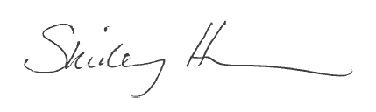

List of References

SCCS Notes of Guidance for the Testing of Cosmetic Substances and Their Safety Evaluation, 9th Revision, 29 September 2015 (SCCS/1564/15)
European Commission database on cosmetic ingredients (Cosing) http://ec.europa.eu/consumers/cosmetics/cosing/
Cosmetic ingredient review http://www.cir-safety.org/

METHOD OF MANUFACTURE / GMP CERTIFICATION

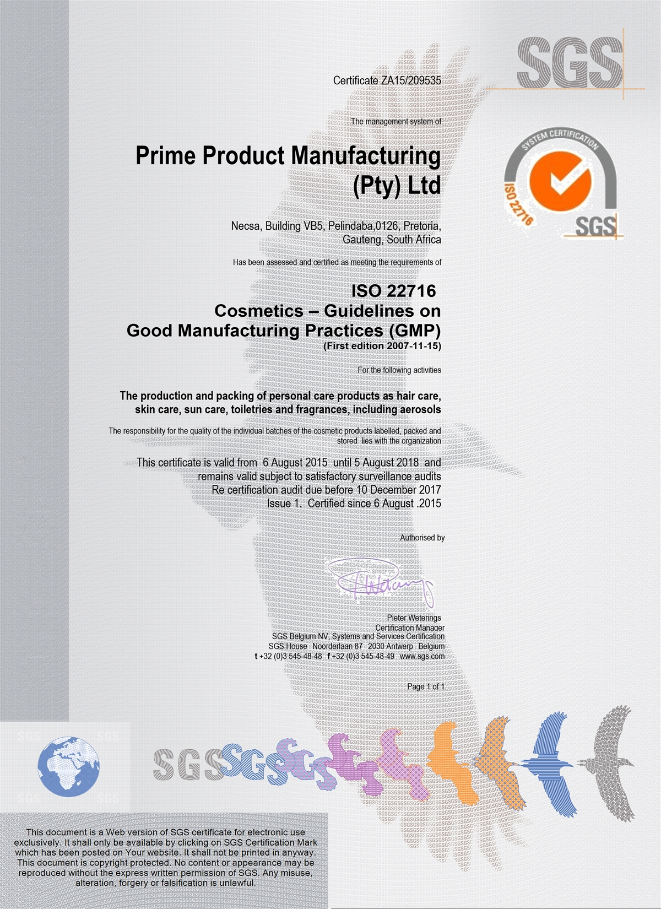

PROOF OF EFFECT CLAIMED

This product makes no direct or implied claims and consequently no proof is required.

ANIMAL TESTING STATEMENT

To the best of our knowledge, the manufacturer and his suppliers have not carried out or commissioned any animal testing for the purpose of developing new cosmetic products.

The statement below is a confirmation of the company policy:

RégimA Skin Treatments
CK92/05371/23
VAT No. 4590131043

Tel: 011 615 2869 or 011 622 7827
Fax: 011 616 8008
Cell: 0836537020
e-mail: jax@regima.com

POSTAL ADDRESS: PO BOX 9523 Edenglen 1613
PHYSICAL ADDRESS: 20 River Road Morninghill Bedfordview 2007 RSA

Animal Testing Compliance Statement

This letter is to serve as testimony as to the practice of animal testing, and confirm that RégimA Skin Treatments has not, nor will not engage in any practice that involves animal testing in any form.

RégimA Skin Treatments hereby confirms neither the manufacturer nor RégimA Skin Treatments itself have commissioned or carried out any form of animal testing during the course of product development. This applies to any and all activities performed as part of the development process, including, but not restricted to: R&D, stability testing, safety and toxicology assessments, suitability studies or any other facet related to the product’s development.

Appendix 1: Safety Data Sheets or Ingredient Specifications

Safety data sheets and technical data sheets for the ingredients are maintained electronically with the PIF by the Responsible Person. They are available on request.

Appendix 2: Microbial Challenge Test

A microbial challenge test is maintained electronically with the PIF by the Responsible Person. It is available on request.

Appendix 3: Certificates of Allergen Content

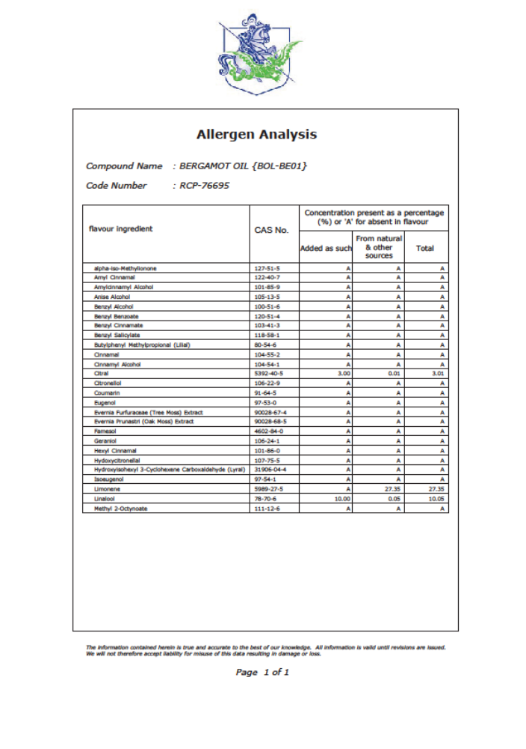

Appendix 4: Miscellaneous

The stability report, packaging material information and product carton insert are maintained electronically with the PIF by the Responsible Person. They are available on request.

